1. Show that if you define more than the MAX number of variables, then you error:

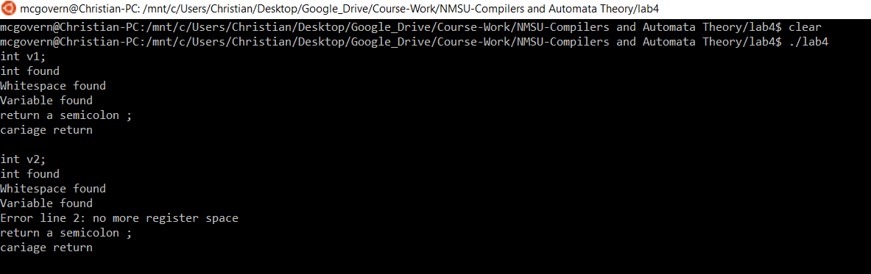

1. Show that you cannot declare a variable more than once

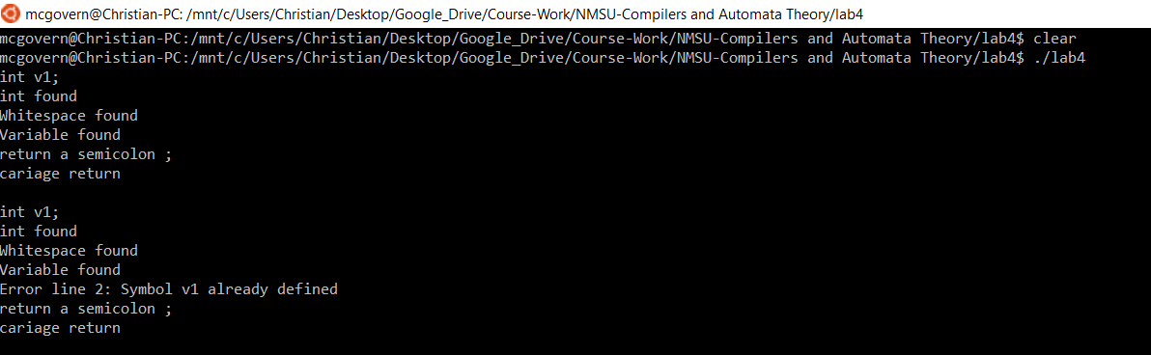

1. Show that you cannot use a variable that is not defined

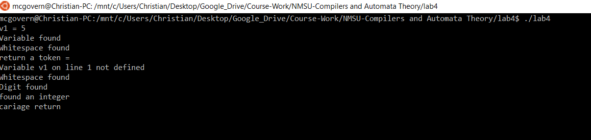

1. Show that a declared variable can be set and used (left and right hand side).

